One-Sample t Test – Example 1 (Stats Ability)

Does the statistics ability of KSU graduates differ from the national average? The average on the national statistics exam is μ = 5.8.

Step 1. State your hypotheses.
a. Is it a one-tailed or two-tailed test?

b. Hypotheses in words:
H_{A}:

H₀:

c. Hypotheses in symbols:
H_{A}:

H₀:

Step 2. Set the significance level ➔ α = .05 Determine t_{crit}. t_{crit} = _________

Step 3. Select and compute the appropriate statistical test.

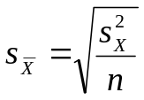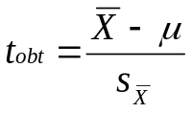
KSU  stats score  (X) |  | X – | (X –)²
10
15
13
5
8
7
9
9
10
13

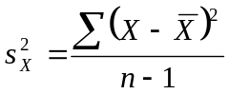

Step 4. Make a decision. Determine whether the value of the test statistic is in the critical region. Draw a picture. Label t_{crit} and t_{obt}.
Is t_{obt} in the critical region? ___________
Should you reject or retain the H₀? ___________

Step 5. Report the statistical results.

Step 6. Write a conclusion.

Step 7. Compute the estimated d.

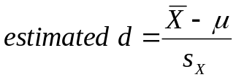

Step 8. Compute r² and write a conclusion.
